"How did an old circus elephant end up in a Queensland Valley and an Australian author's book?"
Those who usually take the pilgrimage to Currumbin Creek's Elephant Rock for Anzac Day will have to change their plans this year due to Covid-19. The spectacular dawn service has drawn people from across Australia to reflect on the sacrifices of our veterans and front-line services in a hauntingly beautiful location, making the area famous.
A not-so-well-known event occurred in Currumbin in the 1990's when two old circus elephants were retired to Currumbin Valley? Author Donna Munro lived in Currumbin at the time. Her deep love of animals and a particular fondness for elephants made her intrigued by their plight. The ban of exotic circus animals on the Gold Coast was first made by Council in 2009 but was later overturned and lifted in 2013. It wasn't until as recently as 2016 the ban was reinstated. Most of the elephants were retired to a sanctuary in Victoria. Two elephants on a property in Currumbin Valley may have relocated later, or they spent their last days roaming the bush in freedom. Locals recollect it, but with no media evidence, it now seems like folklore, so why not include it in a piece of fiction?
The intriguing story made a unique backdrop for Munro's latest contemporary women's fiction Elephant Creek. The Australian author's last stand-alone story of The Zanzibar Moon Series.
"I love including a feisty woman, a gorgeous man, animals, children and family — to tug at reader's heartstrings. Everyone can relate to loving a child or a pet, and falling in love," says Munro.
Munro travelled Australian in her twenties before marrying and settling on the Gold Coast but now calls the Sunshine Coast home. She says. "I guess it's a sea change to a quieter sea change." Munro is hoping to build a writing culture by offering free writing classes online. It began as a physical class, but when Covid-19 sent people into lockdown, we went virtual as a small community that's building. We focus on how to write a book.
With self-isolation boredom setting in for many, if you've been considering writing a book now's the time to get serious about it. "With my publishing experience, tutoring and being the Administrative Officer of Romance Writers of Australia, I know I'm providing an encouraging, nurturing base for anyone interested in the craft. It's on Facebook at https://www.facebook.com/groups/216927456035361 We are focussing on how to write a book and both non-fiction and fiction writers have joined, but we'll discuss anything writing-related," says Munro.
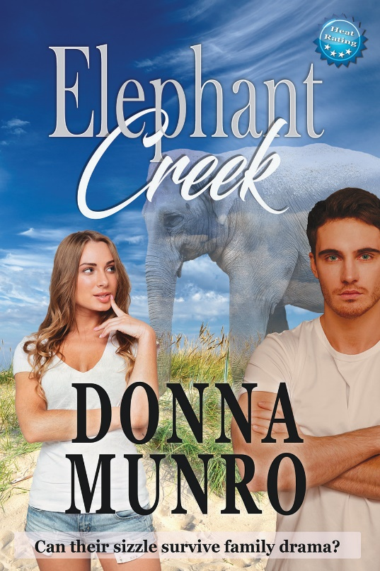
Book Blurb:
Steamy romantic suspense set on the Gold Coast will intrigue and delight readers.
Emma Jarvis has a dilemma — keep dating rock-star handsome Wade or pursue her crush on sexy, silent, probably-married Noah?
Noah Cooper and his Down's Syndrome daughter, Hope, are due for a fresh start. But a car accident propels Emma into their secretive world. Will Noah put his guard down long enough to let love back into his life?
Emma finds, convincing Noah of a police conspiracy is one thing. Avoiding combusting when she's near him is a totally different predicament.
Noah has enough problems without falling for delightful, Emma and her lust-inducing cut-off shorts. His wife's abandonment. Proving his father's innocence. And Hope, beginning mainstream school where bullies lurk.
When Noah learns his dead brother's, son, Jai is with Emma's family, he must cut contact with Emma or lose what's most precious to him.
But when Jai and Hope go missing can the adults unite to find the missing children in the Australian bush? Will an old circus elephant be the key to bonding them before it's too late?
The sequel to The Zanzibar Moon brings all three books to a final enthralling, emotional conclusion in a stand-alone story filled with passion and heat.

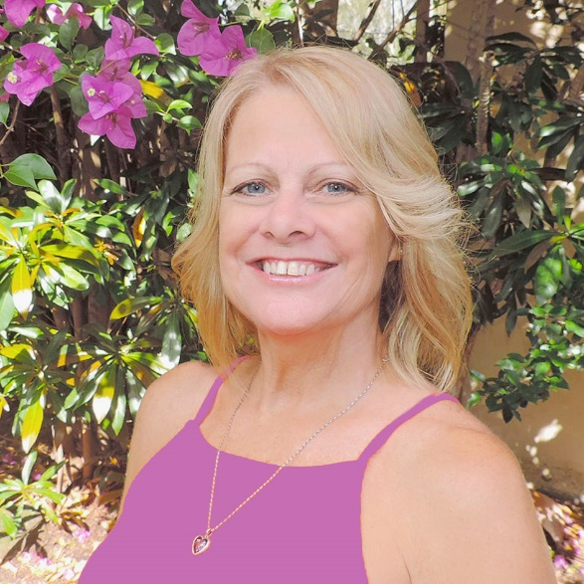
ISBN: 978-0-6480194-6-6 (paperback)

RRP: $25.99

AUTHOR: Donna Munro

PUBLISHER: Warm Witty Publishing
COVER DESIGN: Donna Munro Graphic Design
RELEASED: 25.03.2020
Subjects: Contemporary Women's Fiction, Romance Fiction, General Fiction.

Donna Munro is the author of The Zanzibar Moon (June 2017), Kendwa's Secret (2018) and Elephant Creek (2020) and is a successful freelance writer and graphic designer.

Visit her website at www.warmwittywords.com.au or follow her on Social Media linktr.ee/donnadmunro

Purchase Elephant Creek as a paperback or ebook at the author’s website
or Amazon

If you would like to interview the author, please email:
donna@warmwittywords.com.au or phone 0474 207 342

